Stable Diffusion

3 different categories for text to image

Media/Social Networking

Images-: newspaper and television

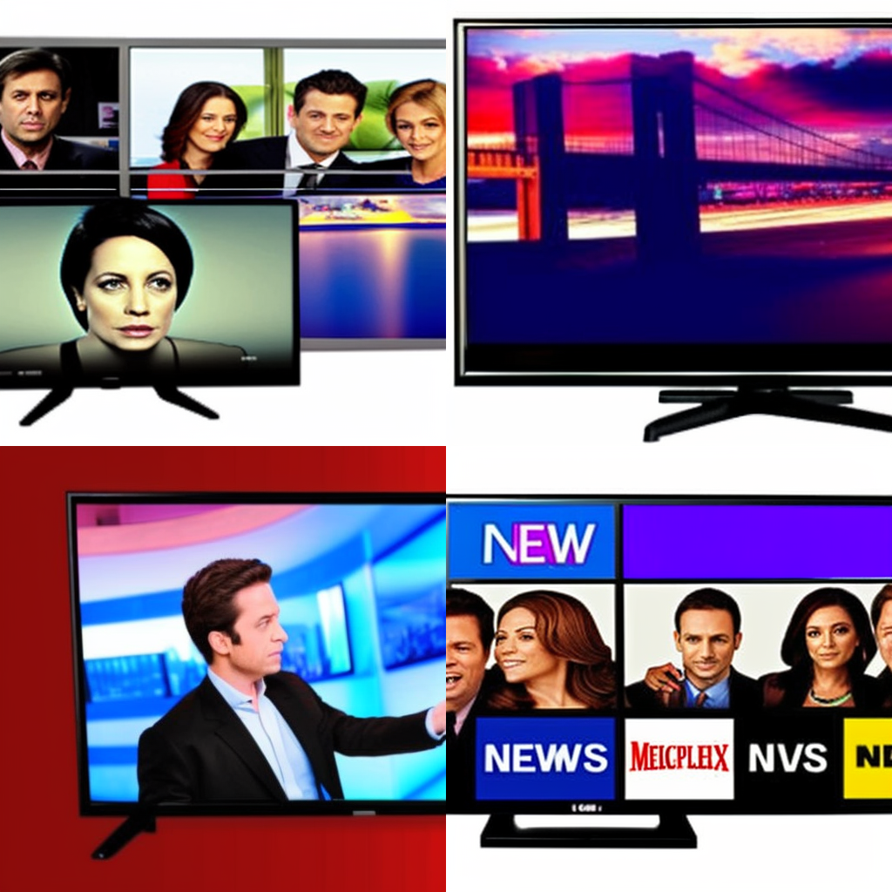

News in Television

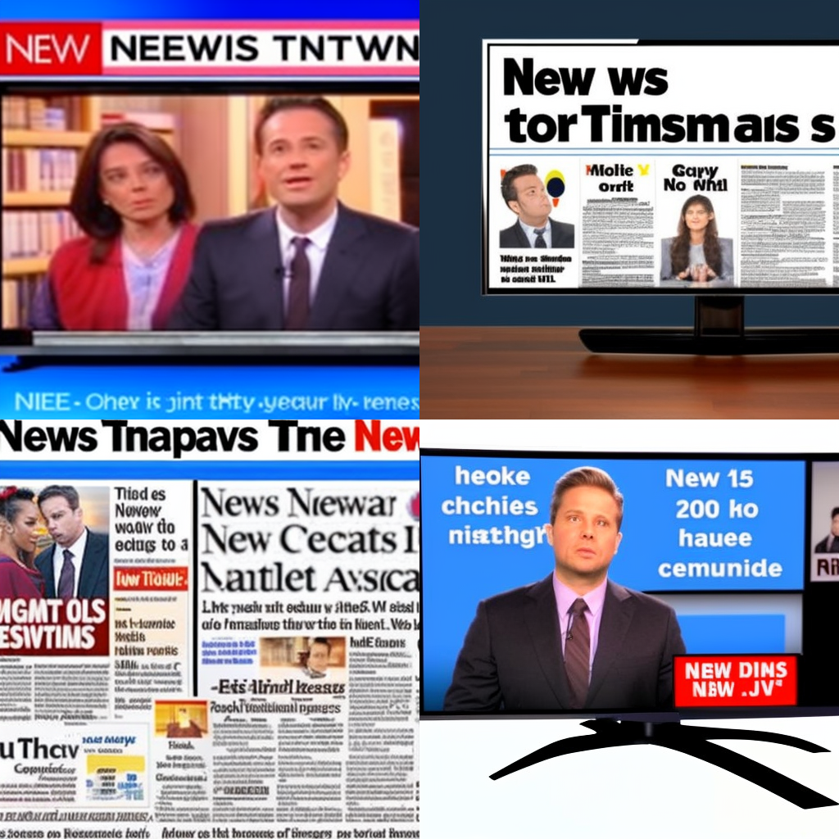

News headlines on television

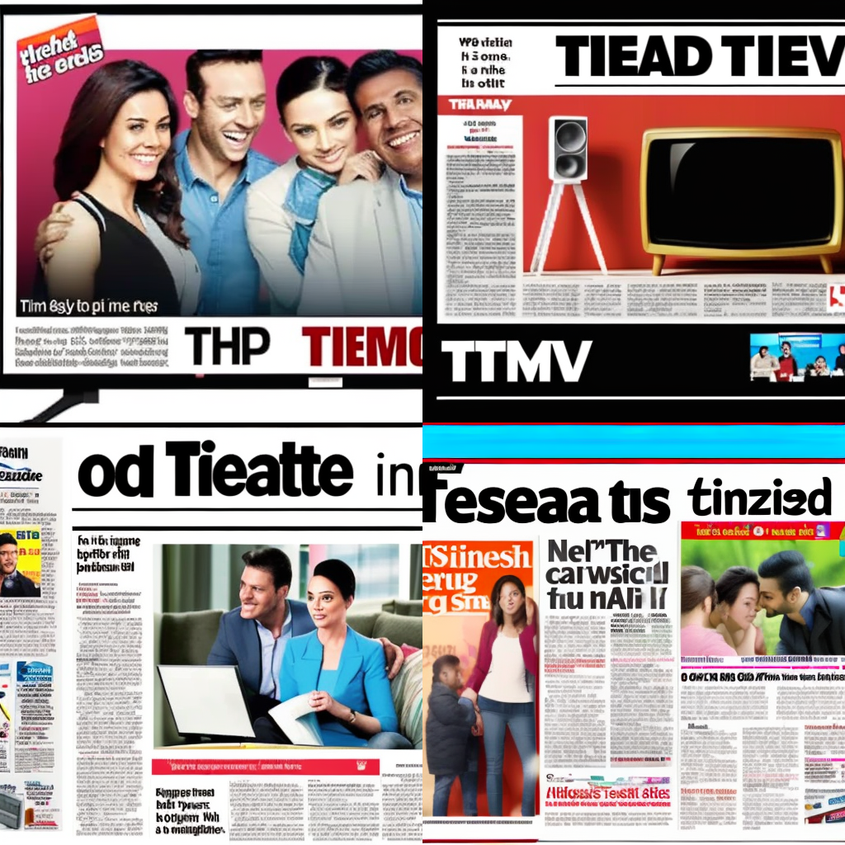

Ad of television in newspaper

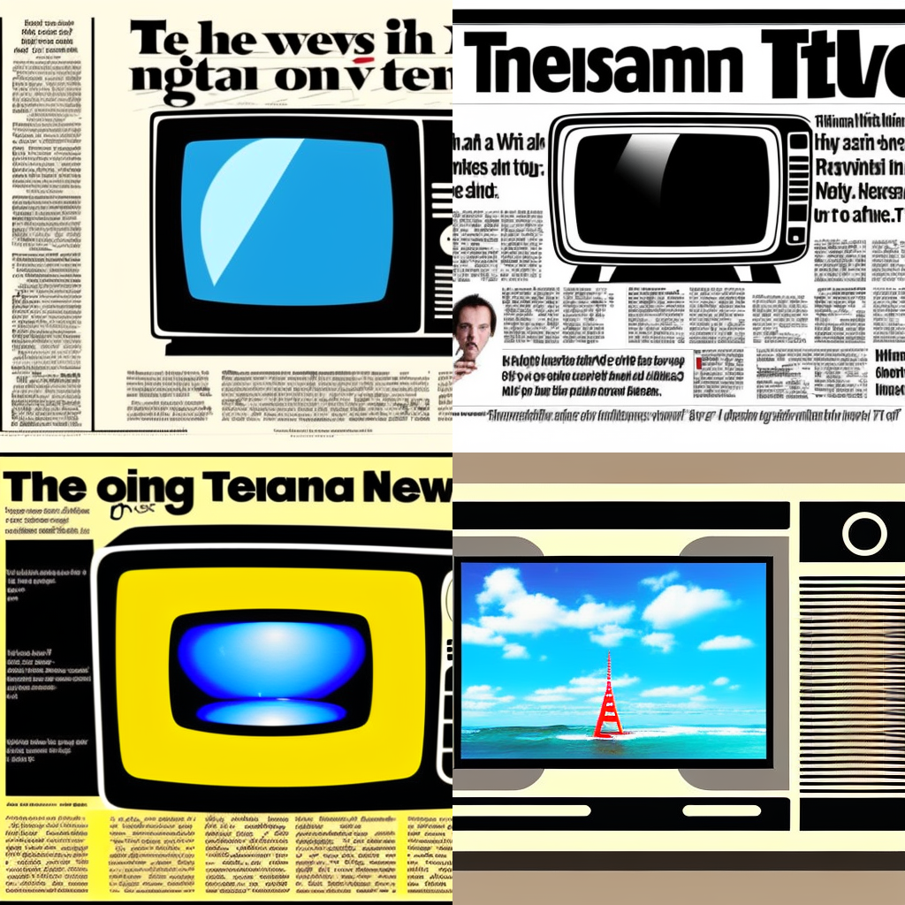

Ad of television in newspaper, digital art

Travel/Tourism

Images-: beaches and mountains

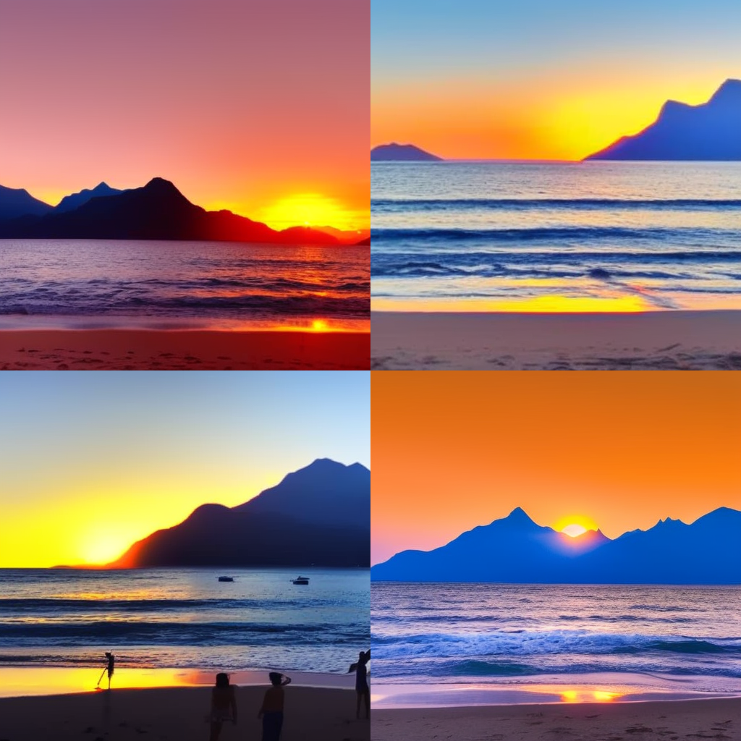

A sunset on the beach with mountains in the background

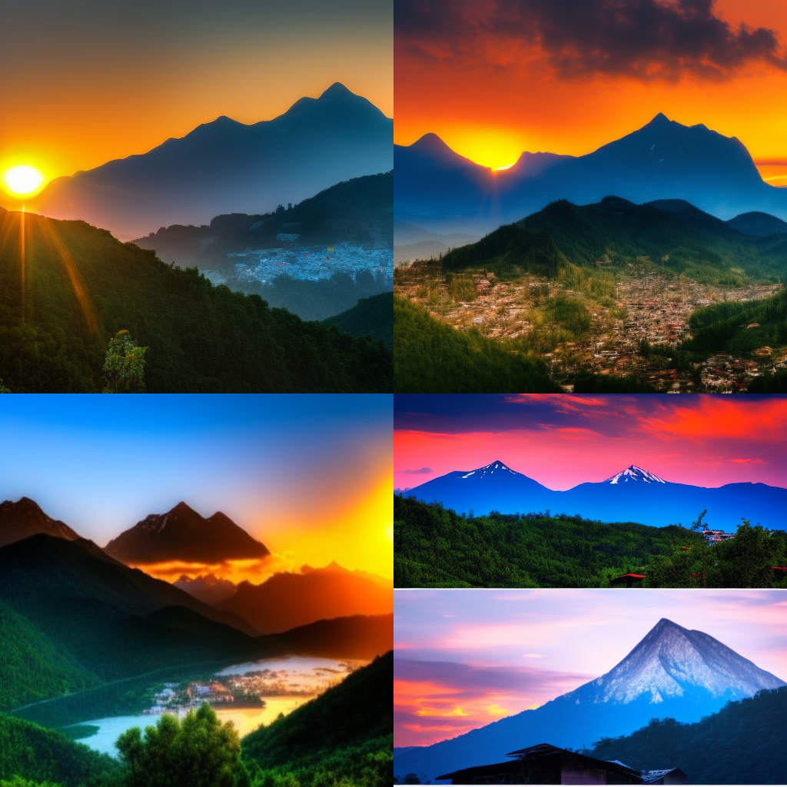

A scene of a mountain and a sunset from between the mountains

Munchies

Images- eating food and eating place(cafe/stall)

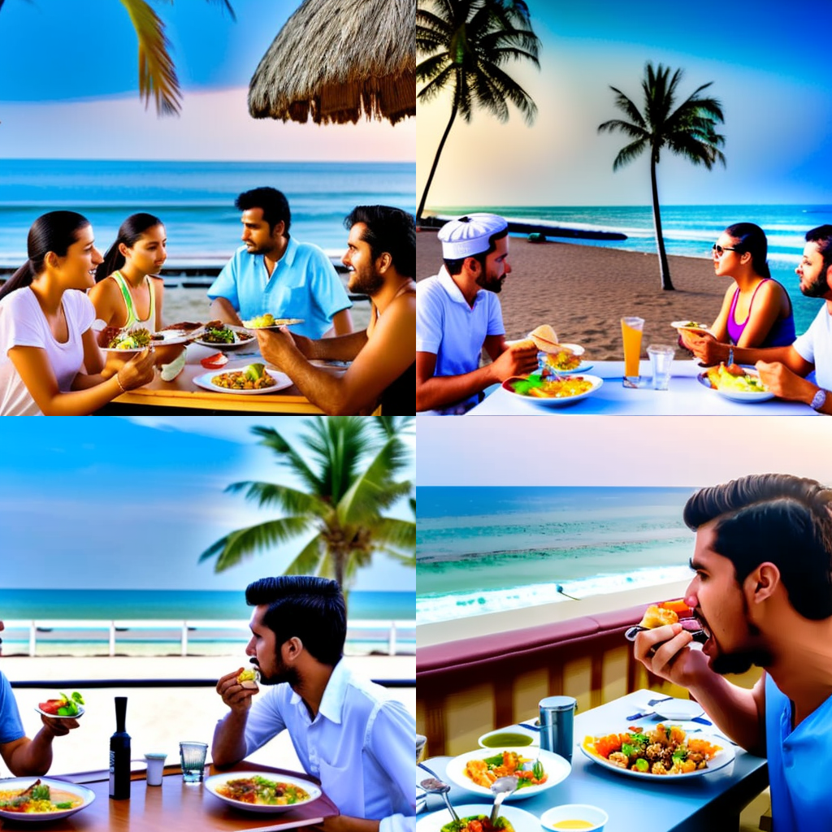

eating food near beach

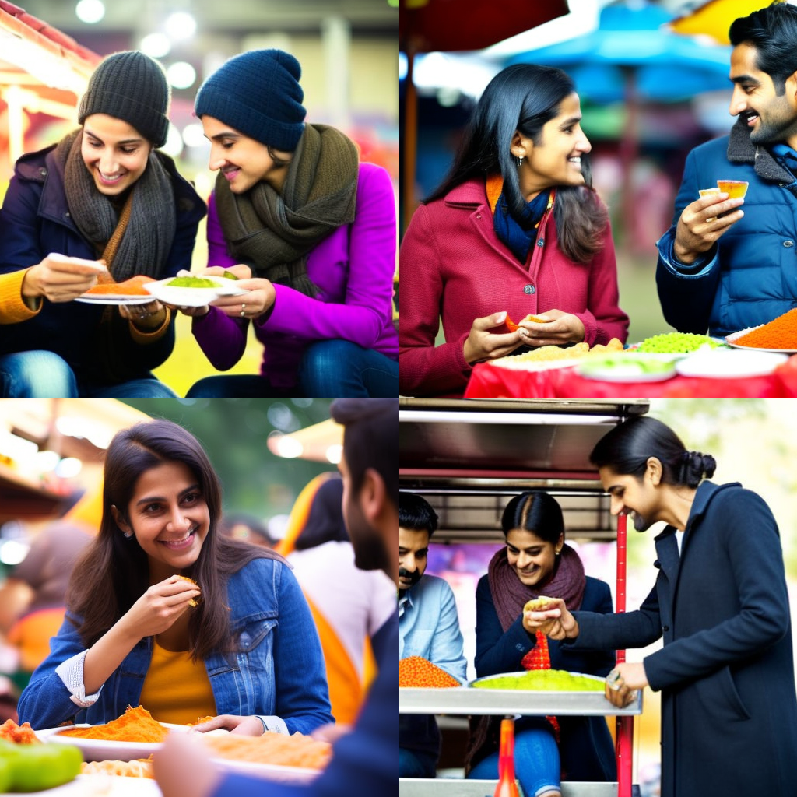

eating snacks

Negative prompt-noodles, burger